**Norwich Baroque**

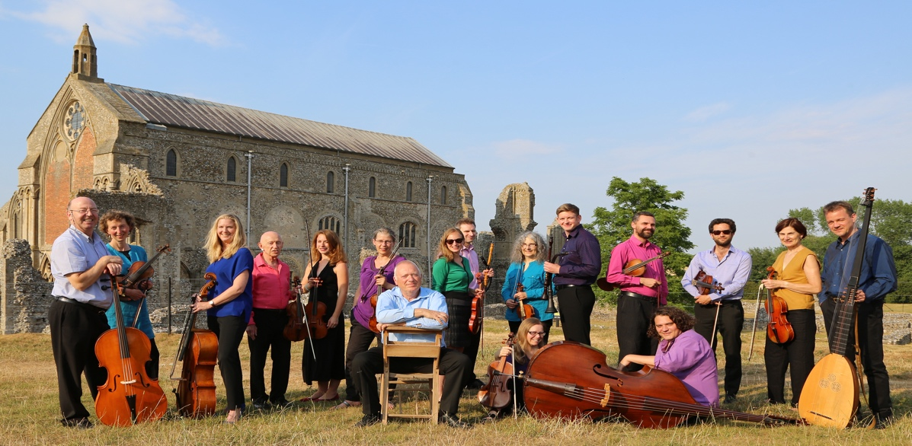

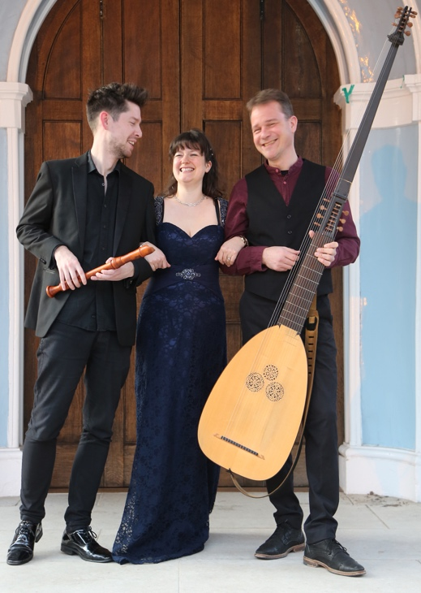© Paul Hurst

**Jonathan Sage,** *clarinet*

**Eleanor Kornas,** *piano*

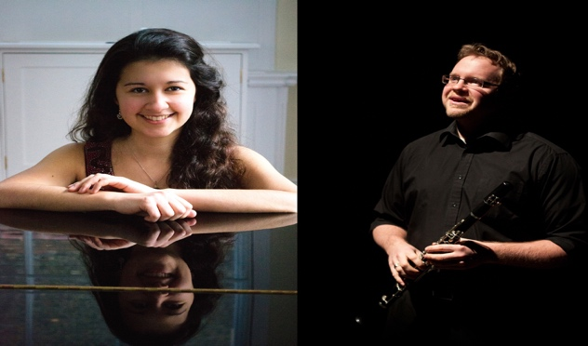

**Civitas Ensemble**

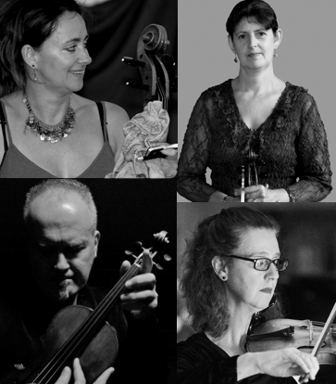

**Heath Quartet**

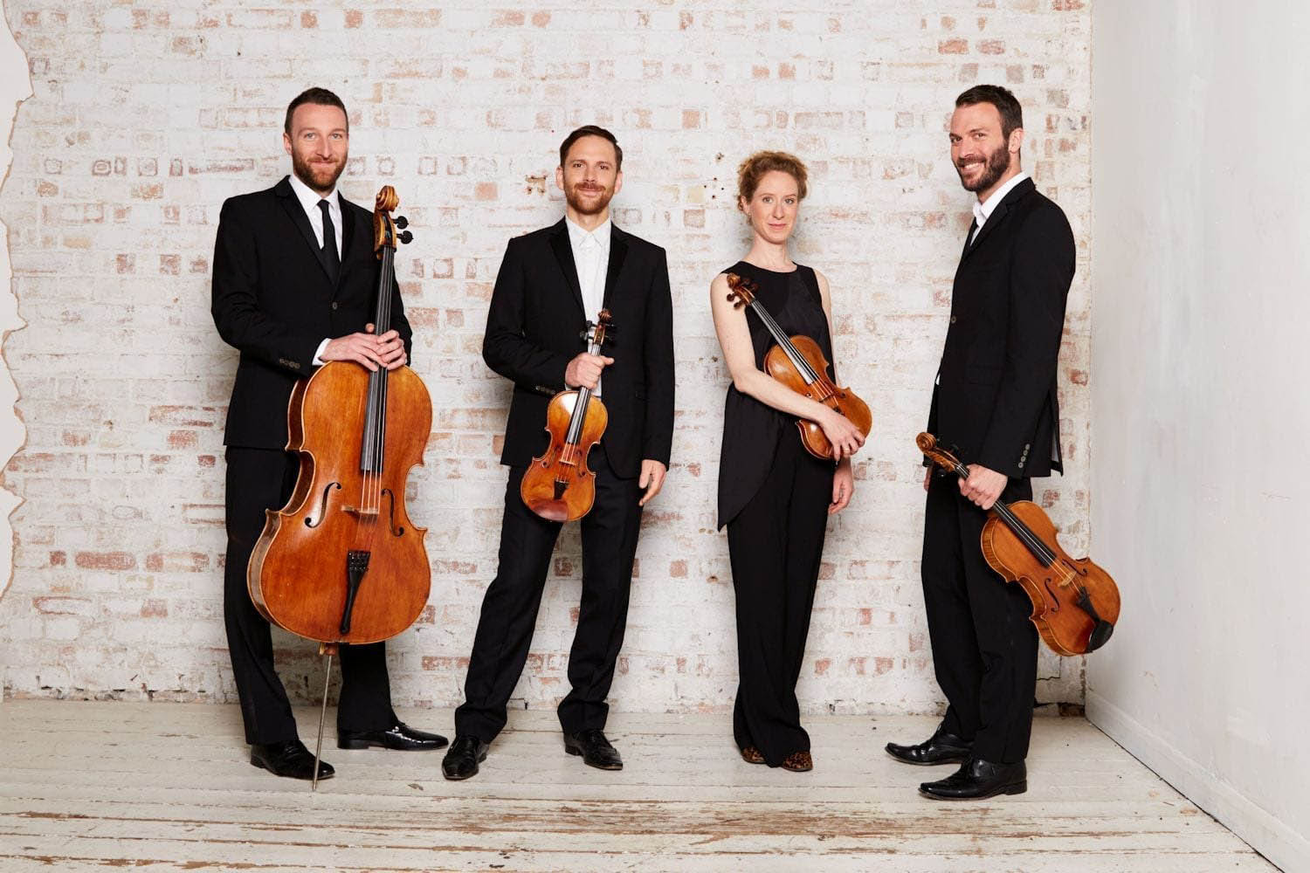

*© Simon Way*

**Xuefei Yang**

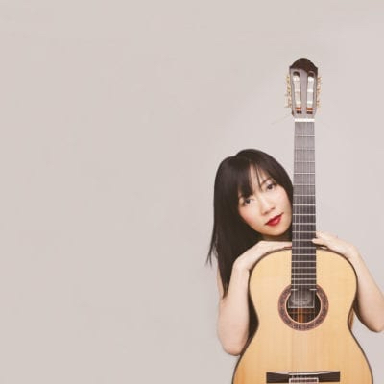

© Neil Muir